ALP-PGM 1a
WRITE AN ALP TO SEARCH A KEY ELEMENT IN A LIST OF 16 BIT N NUMBERS USING BINARY SEARCH ALGORITHM.

.MODEL SMALL
.DATA
A DB 50D,40D,30D,20D,10D
LEN DW $-A
M1 DB 10,13,'KEY IS FOUND$'
M2 DB 10,13,'KEY IS NOT FOUND$'
KEY DB 40D
.CODE
MOV AX,@DATA
MOV DS,AX
MOV BX,LEN
DEC BX
N2: MOV CX,BX
LEA SI,A
N1: MOV AL,[SI]
INC SI
CMP AL,[SI]
JBE NOSWAP
XCHG AL,[SI]
MOV [SI-1],AL
NOSWAP:LOOP N1
DEC BX
JNZ N2
LEA SI,A
MOV DI,SI
ADD DI,LEN
DEC DI
L1: CMP SI,DI
JA NF
MOV BX,SI
ADD BX,DI
SHR BX,01H
MOV AL,KEY
CMP AL,[BX]
JZ FOUND
JA NLOW
MOV DI,BX
DEC DI
JMP L1
NLOW: INC SI
MOV SI,BX
JMP L1
FOUND: LEA DX,M1
JMP FINAL
NF: LEA DX,M2
FINAL: MOV AH,09H
INT 21H
MOV AH,4CH
INT 21H
END

OUTPUT-
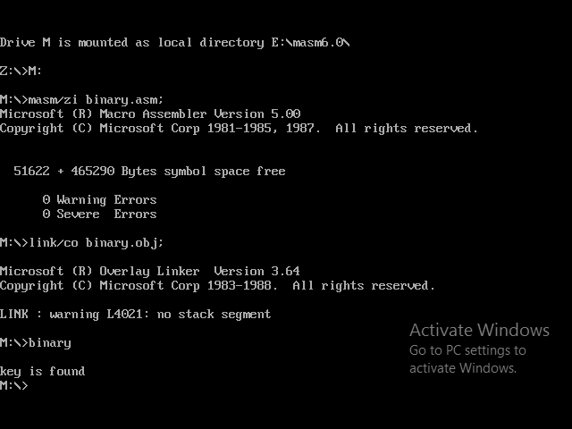

ALP-PGM 2a
WRITE AN ALP TO READ AN ALPHANUMERIC CHARACTER AND DISPLAYS ITS EQUIVALENT ASCII CODE AT THE CENTER OF THE SCREEN.

.MODEL SMALL
.DATA
M1 DB 10,13,"ENTER THE CHARACTER $"
M2 DB "THE ASCII VALUE IS $"
.CODE
MOV AX,@DATA
MOV DS,AX
MOV AH,06H
MOV AL,0D
MOV CX,00H
MOV BH,0CEH
MOV DH,24D
MOV DL,79D
INT 10H
LEA DX,M1
MOV AH,09H
INT 21H
MOV AH,01H
INT 21H

MOV AH,00H
MOV BX,10D
MOV CX,00H

L1:MOV DX,00H
DIV BX
PUSH DX
INC CX
CMP AX,00H
JNZ L1

MOV AH,2H
MOV BH,0H
MOV DH,12D
MOV DL,39D
INT 10H

LEA DX,M2
MOV AH,09H
INT 21H

L2: POP DX
ADD DL,30H
MOV AH,02H
INT 21H
DEC CX
JNZ L2

MOV AH,4CH
INT 21H
END

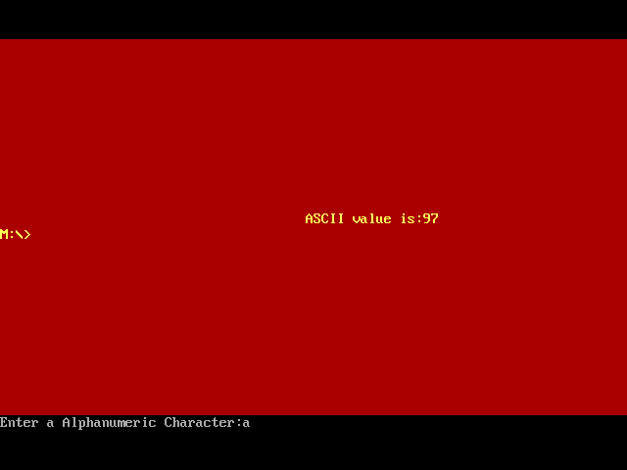

ALP-PGM 3a
WRITE AN ALP TO AN 8BIT NUMBER FROM THE KEYBOARD AND CHECK WHETHER IT IS A PRIME NUMBER OR NOT

.MODEL SMALL
.DATA
M1 DB 10,13,"ENTER THE 8 BIT NO$"
M2 DB 10,13,"THE GIVEN NO IS PRIME $"
M3 DB 10,13,"THE GIVEN NO IS NOT PRIME$"
COUNT DB 00H
NUM DB ?

.CODE
MOV AX,@DATA
MOV DS,AX
LEA DX,M1
MOV AH,09H
INT 21H
CALL READ8

MOV CL,AL
MOV CH,00H
MOV BL,01H

L3: MOV AH,00H
DIV BL
CMP AH,00H
JZ L1
JMP L2

L1: INC COUNT
L2: INC BL
MOV AL,NUM
DEC CX
JNZ L3
CMP COUNT,02H
JZ L4
LEA DX,M3
MOV AH,09H
INT 21H
JMP EXIT
L4: LEA DX,M2
MOV AH,09H
INT 21H
EXIT: MOV AH,4CH
INT 21H

READ8 PORC NEAR
MOV AH,01H
INT 21H
SUB AL,30H
MOV BH,AL
MOV AH,01H
INT 21H
SUB AL,30H
MOV AH,BH
AAD
RET
READ8 ENDP
END

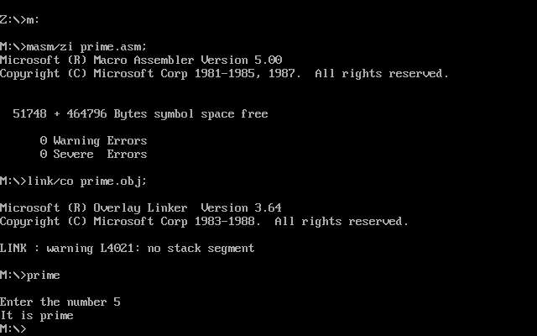

ALP-PGM 4a

WRITE AN ALP TO READ A STRING FROM THE KEYBOARD AND CHECK WHETEHER IT IS A PALINDROME OR NOT

.MODEL SMALL
.DATA
BUFF DB 10
L1 DB ?
STR DB 10 DUP(?)
RSTR DB 10 DUP(?)
M1 DB 10,13,"ENTER THE STRING$"
M2 DB 10,13,"REVERSED STRING IS $"
M3 DB 10,13,"STRING IS PALINDROME $"
M4 DB 10,13,"STRING IS NOT PALINDROME$"

.CODE
MOV AX,@DATA
MOV DS,AX
MOV ES,AX
LEA DX,M1
CALL PRINTF
LEA DX,BUFF
MOV AH,0AH
INT 21H
LEA SI,STR
LEA DI,RSTR
MOV CL,L1
ADD SI,CX
DEC SI

L2: MOV AL,[SI]
MOV [DI],AL
DEC SI
INC DI
DEC CX
JNZ L2

INC DI
MOV AL,'$'
MOV [DI],AL
LEA DX,M2
CALL PRINTF
LEA DX,RSTR
CALL PRINTF

LEA SI,STR
LEA DI,RSTR
MOV CL,L1
MOV CH,00H
CLD
REPE CMPSB
JZ L3

LEA DX,M4
CALL PRINTF
JMP EXIT
L3: LEA DX,M3
CALL PRINTF

EXIT: MOV AH,4CH
INT 21H

PRINTF PROC NEAR
MOV AH,09H
INT 21H
RET
PRINTF ENDP
END

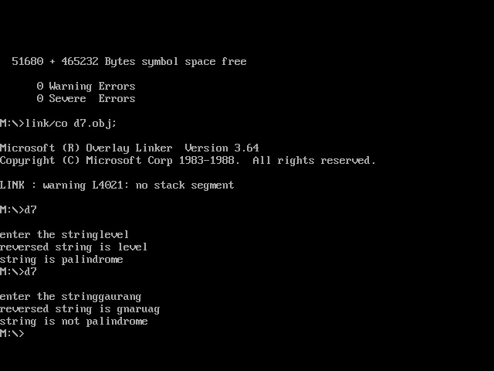

ALP-PGM 5a
WRITE AN ALP TO READ TWO STRINGS, STORE THEM IN LOCATIONS STR1 AND STR2. CHECK WHETEHER THEY ARE EQUAL OR NOT AND DISPLAY APPROPRIATE MESSAGES. ALSO DISPLAY THE LENGHT OF THE STORED STRINGS.\

.MODEL SMALL
.DATA
M1 DB 10,13,"ENTER 1ST STRING: $"
BUFF1 DB 100
LEN1 DB ?
STR1 DB 100 DUP(?)
M2 DB 10,13,"ENTER 2ND STRING: $"
BUFF2 DB 100
LEN2 DB ?
STR2 DB 100 DUP(?)
M1LEN DB 10,13,"LEN OF STR1 IS : $"
M2LEN DB 10,13,"LEN OF STR2 IS : $"
M3 DB 10,13,'STRINGS ARE EQUAL!$'
M4 DB 10,13,'STRINGS ARE NOT EQUAL.$'

.CODE
MOV AX,@DATA
MOV DS,AX
MOV ES,AX

LEA DX,M1 ;ENTER STRING MESSAGE
CALL PRINTF
LEA DX,BUFF1 ;ENTER STRING 1
CALL PUTS
LEA DX,M2
CALL PRINTF
LEA DX,BUFF2 ;ENTER STRING 2
CALL PUTS
MOV AL,LEN1
CMP AL,LEN2
JNZ NOTEQUAL

;COMPARE STRINGS
MOV CX,00H
MOV CL,LEN1
LEA SI,STR1
LEA DI,STR2
CLD
REPE CMPSB
JZ STREQUAL

NOTEQUAL: LEA DX,M4
CALL PRINTF
JMP EXIT

STREQUAL: LEA DX,M3
CALL PRINTF

EXIT: LEA DX,M1LEN ;PRINT STR1 LEN
CALL PRINTF
MOV DL,LEN1
CALL PRINTL
LEA DX,M2LEN ;PRINT STR1 LEN
CALL PRINTF
MOV DL,LEN2
CALL PRINTL
MOV AH,4CH
INT 21H

PRINTF PROC NEAR
MOV AH,09H
INT 21H
RET
PRINTF ENDP

PUTS PROC NEAR
MOV AH,0AH
INT 21H
RET
PUTS ENDP

PRINTL PROC NEAR
MOV AX,00H
MOV AL,DL
MOV BX,10D
MOV CX,00H
L1: MOV DX,00H
DIV BX
PUSH DX
INC CX
CMP AX,00H
JNZ L1
L2: POP DX
ADD DX,30H ;CONVERT TO ASCII
MOV AH,02H ;CHAR DISPLAY
INT 21H
DEC CX
JNZ L2
RET
PRINTL ENDP
END

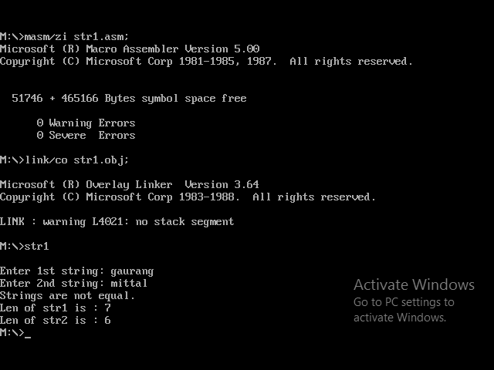

ALP-PGM 6a

WRITE AN ALP TO GENERATE AND PRINT FIRST N FIBONACCI NUMBERS.

.MODEL SMALL
.DATA
M1 DB 10,13,'ENTER THE NUMBER: $'
M2 DB 10,13,'0 1 $'
N DW ?
A DW 0H
B DW 01H
.CODE
MOV AX,@DATA
MOV DS,AX
LEA DX,M1
CALL PRINTF
CALL READ8
MOV CX,N ;COUNTER TILL NTH NBER
SUB CX,02H ;DECREMENT BY 2 AS FIRST 2 ARE PRINTED
LEA DX,M2
CALL PRINTF

LOOP1: ;FIBONACCI LOOP
MOV AX,A
ADD AX,B ;A = A + B ; C = AX
MOV A,AX ;RESTORING A AS C
MOV DI,CX ;STORING THE COUNTER TEMPORARILY IN DI
MOV DX,AX ;STORED IN DL TO PRINT NUMBER
CALL PRINT8 ;DISPLAY NTH NBER
MOV AX,A
XCHG AX,B ;A=B AND B=A(WHICH IS C)
MOV A,AX
MOV CX,DI ;RESTORING COUNTER
LOOP LOOP1
MOV AH,4CH
INT 21H

;PROCEDURE TO DISPLAY 8 BIT CHARACTER IN DECIMAL VALUE IN DL
PRINT8 PROC NEAR
MOV AX,00H
MOV AL,DL
MOV BX,10D
MOV CX,00H
LOOP_PUSH:
MOV DX,00H
DIV BX
PUSH DX
INC CX
CMP AX,00H
JNE LOOP_PUSH
LOOP_POP:
POP DX
ADD DX,30H ;CONVERTING THE NBER TO ASCII VALUE
MOV AH,02H
INT 21H
LOOP LOOP_POP
MOV DL,' ' ;PRINTING SPACE
MOV AH,02H
INT 21H
RET
PRINT8 ENDP

;PROCEDURE TO READ 8 BIT NBERS & STORE IN AL
READ8 PROC NEAR
MOV AH,01H ;READING 1ST NIBBLE
INT 21H
SUB AL,30H
MOV BL,AL
MOV AH,01H ;READING 2ND NIBBLE
INT 21H
SUB AL,30H
MOV AH,BL
AAD ;ASCII ADJUST BEFORE DIVISION
MOV N,AX
RET
READ8 ENDP

;PROCEDURE TO PRINT MESSAGE
PRINTF PROC NEAR
MOV AH,09H
INT 21H
RET
PRINTF ENDP
END

